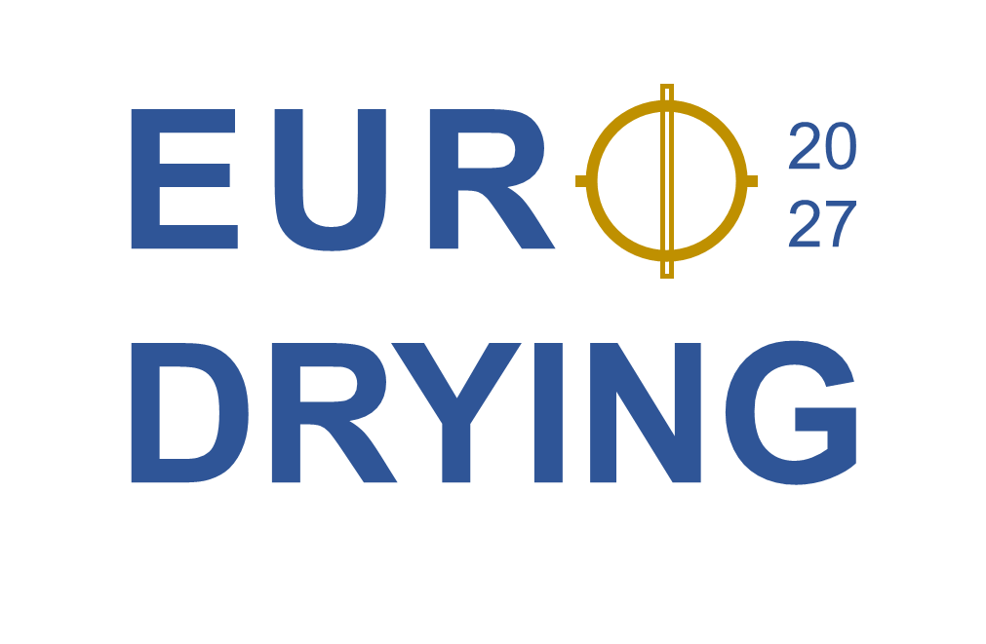

SPONSORING FORM
Event #843
July 5th – July 7th, 2027 in Magdeburg, Maritim Hotel

The following packages are offered:
 | Diamond | Gold | Silver | Bronze
Company logo & link to your website in our online communication* | x | x | x | x
Company logo at the venue;  2 large vertical banners featuring the logo of all sponsors, displayed in central area | x | x | x | x
Company logo in EuroDrying Book of Abstracts and program booklet | x | x | x | x
Verbal acknowledgment during opening and closing ceremonies as well as the conference dinner. Logo will be featured on a slide during these presentations. | x | x | x | x
Free delegate (1) for all events, including conference dinner | x | x | x | -
Company banner in main conference room. One banner per company.** | x | x | - | -
Exhibition package (1)*** | x | - | - | -
Price (netto, EUR) | 6000 | 5000 | 3500 | 1500
* includes web page, email communication, social media (e.g., LinkedIn)
** Banner provided by company.
*** Includes one industry ticket.
For sponsoring, contact: eurodrying2027@ovgu.de
with package and sponsor information (name, address, contact, e-mail address)
Additional sponsoring possibilities can be discussed with
the Chairs of the conference: eurodrying2027@ovgu.de

